SIMATS ENGINEERING (SAVEETHA SCHOOL OF ENGINEERING)
Course Code & Title: | ECA5604 -5G/6G COMMUNICATION | Course Faculty: | Dr.K.Sathish
Student Name: | Velamuri Bhanodhay | Reg. No.: | 192412330
Dept / Batch: | BE.ECE / 2024 | Date: | /7/2026
Lab Observation

Experiment 6 : 5G NR Frame Structure Analysis with Different Subcarrier Spacing

Objective 1: To analyze different Subcarrier Spacing (SCS) values used in 5G NR numerology.

Matlab Code:

clc;
clear;
close all;
scs = [15 30 60 120 240]; % Subcarrier Spacing (kHz)
mu = 0:4; % Numerology Index
bar(scs)
grid on
set(gca,'XTick',1:5)
set(gca,'XTickLabel',mu)
xlabel('Numerology Index (\mu)')
ylabel('Subcarrier Spacing (kHz)')
title('5G NR Subcarrier Spacing for Different Numerologies')

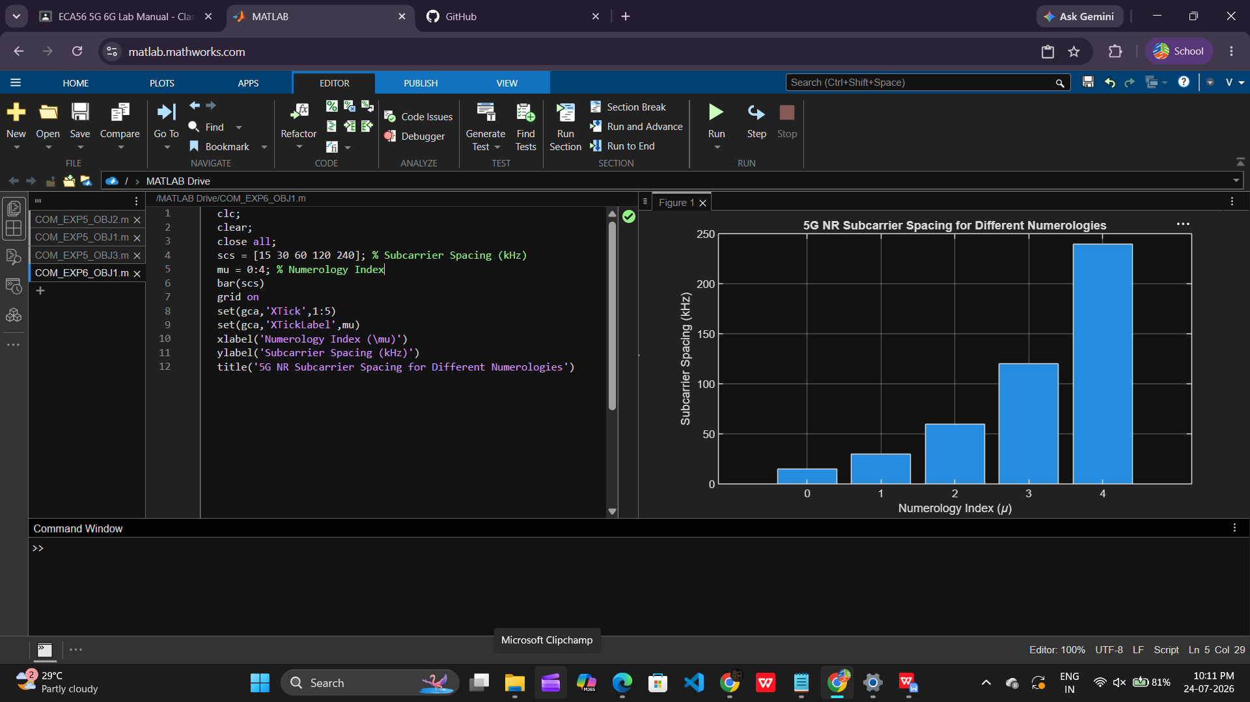

Objective 2: To compare the slot duration corresponding to different Subcarrier Spacing values in 5G
NR.

Matlab Code:

clear;
close all;
scs = [15 30 60 120 240]; % Subcarrier Spacing (kHz)
slot = [1 0.5 0.25 0.125 0.0625]; % Slot Duration (ms)
plot(scs, slot, 'o-', 'LineWidth', 2)
grid on
xlabel('Subcarrier Spacing (kHz)')
ylabel('Slot Duration (ms)')
title('5G NR Slot Duration for Different Subcarrier Spacing')

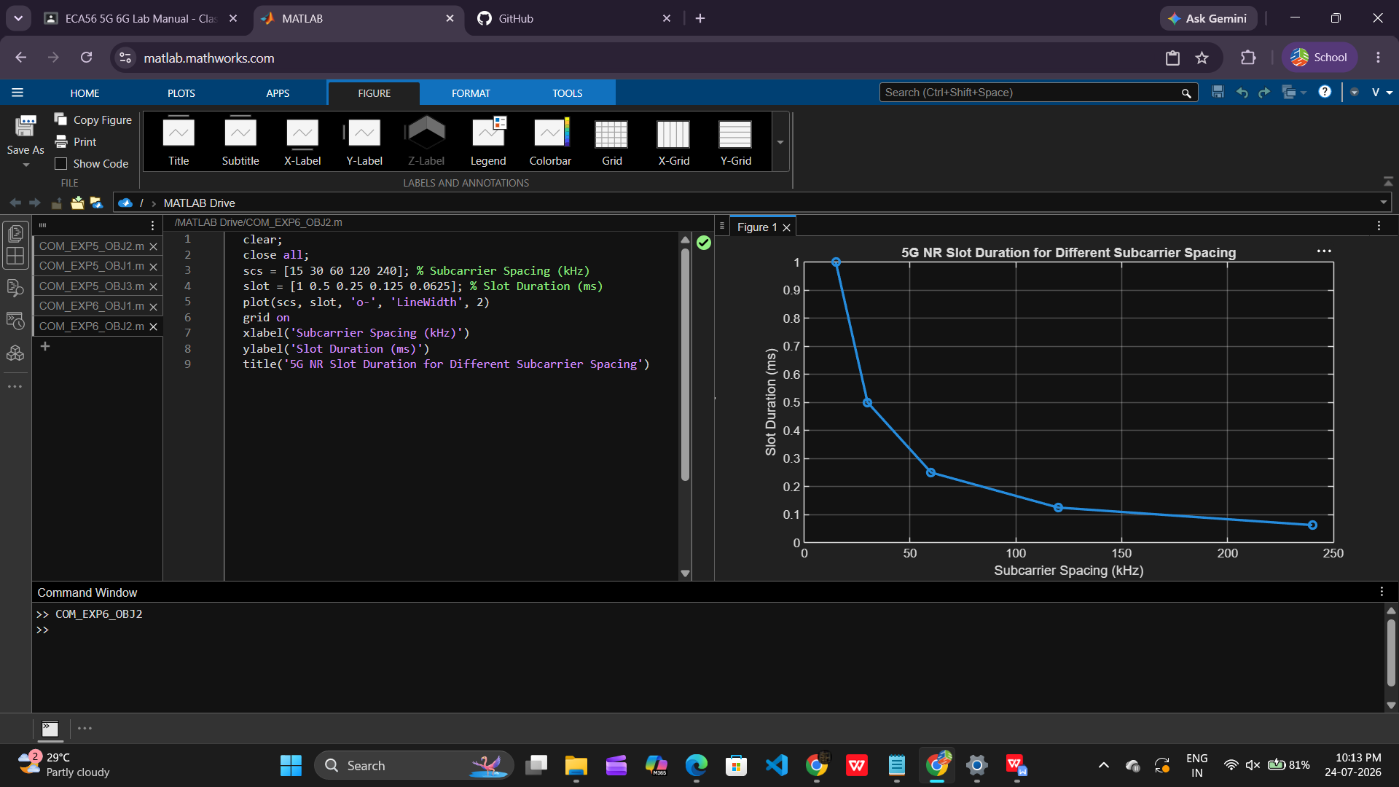

Objective 3: To study the number of OFDM symbols present in a 5G NR slot for normal cyclic prefix.

Matlab Code:

clc;
clear;
close all;
scs = [15 30 60 120 240]; % Subcarrier Spacing (kHz)
symbols = [14 14 14 14 14]; % OFDM Symbols per Slot
figure
bar(scs, symbols)
grid on
xlabel('Subcarrier Spacing (kHz)')
ylabel('Number of OFDM Symbols')
title('OFDM Symbols per Slot for Different Subcarrier Spacing')
ylim([0 16])

